**Asset Management System**

Use Case (Requirement) Document

10th Mar 2024

Ver 0.0Draft1

Document Identification

| Project Code |  |
| --- | --- |
| Project Name | Asset Management System |
| Document Id |  |
| Project Start Date | 05/02/2024 |
| Project End Date | 10/03/2024 |
| Project Type |  |
| Project Manager |  |
| Project Manager Cell No |  |

Client Detail

| Client Name |  |
| --- | --- |
| Contact Person |  |
| Contact Person Email Id |  |
| Contact Person Cell No |  |

Version History

| Version | Date | Author(s) | Comment | Reviewed By |
| --- | --- | --- | --- | --- |
| Ver0.0 Draft1 | 10th Mar, 2024 | Abhinandan Kumar | Initially Created |  |

Contents

1 Introduction 4

1.0 Purpose 4

1.1 Scope 4

1.2 Target Audience 4

1.3 Document Management 4

1.4 Reference Document 4

2 Overview 5

2.0 Assumptions 5

2.1 Constraints 5

2.2 Technologies 5

2.3 Exclusions 5

3 Top Level System Overview 6

4 Use Cases 7

4.0 UC-000: High Level Use Case Association 7

4.1 High Level Use Case – Bug Analyzer 9

4.1.1 UC-001: Register User 9

4.1.2 UC-002: Login User 11

4.1.3 UC-004: Register Bug 12

4.1.4 UC-004: Display Bug Dashboard 14

4.1.5 UC-005: Display project Bugs 15

4.1.6 UC-006: Edit bug 16

4.1.7 UC-007: Display Assigned Bugs 18

4.1.8 UC-008: Logout 19

5 Processing Details 21

5.1 PD01: Bug Analyzer 21

5.1.1 PD01A: Register User 21

5.1.2 PD01B: Register Bug 21

5.1.3 PD01C: Display Bug Dashboard 22

# Introduction

## Purpose

The purpose of this document is to provide insight into the use cases related to the “Asset Management” which will be used as the baseline document for further design, development, and testing of the application.

## Scope

This document covers the business use case of “Asset Management” and assumptions which are used at the time of design & development of the project.

## Target Audience

The target audience for this use case document includes business, technical, and project management stakeholders.

## Document Management

The requirements in this use case document shall be traced to the appropriate deliverables in the development and testing phases to ensure that all requirements are properly implemented and tested.

## Reference Document

* Extended Resources Tasks From 19 Jan.xlsx

# Overview

The Objective of Asset Management is to :

1. Register new Users
2. Register new assets
3. Assigning assets to user.
4. Editing data of assets.
5. Register new vendors and edit their details

## Assumptions

* The application will work in LAN network only.
* The user's device meets the minimum system requirements for running Application

## Constraints

* Application will be tested on Google Chrome.
* NodeJS 12.18.2 version will be used as the baseline version.

## Technologies

**Languages & Tool:** Node JS, Pug (Template Engine), Express (Environment)

**Operating Systems/Platform:** Windows 11

**Device Databases:** PostgreSQL v14.5.1

## Exclusions

* The execution of the project would be as stated in the above sections. Any other aspect or deviation introduced during the project development will be considered as Out of Scope or Change request and would call for impact analysis in terms of added timeframe and additional charges.

# Top Level System Overview

APPLICATION

**API**

# Use Cases

## UC-000: High Level Use Case Association

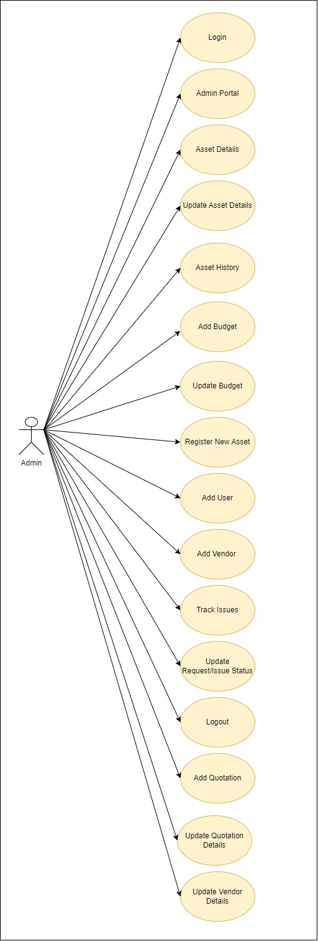

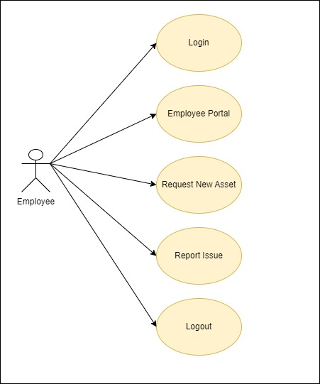

## High Level Use Case – Admin User

### 4.1.1 UC-001: Login

**Purpose**

* + - This use case describes how user will be Log In in the application.

**Actors**

* + - The actor(s) that interact and participate in this use case are: User

**Pre-Conditions**

* + - Application should be running on device.

**Post-Conditions**

* + - User should be redirected to the Admin Portal/Employee Portal screen depending upon user role in the application.

**Basic Flow**

* + - Login screen will be displayed.
    - User enters the login details.
    - User clicks on ‘Log In button.
    - User will be logged in the application.

**Alternate Flow (User is not registered)**

* + - User clicks on ‘Log In’ button.
    - A toast will be displayed with ‘User not found.’

**Failure Case**

* NA

**Validation**

* + - Email: Required and should be in email format.
    - Password: Required and should consist at least 1 special character, 1 number and should be greater than equal to 8 characters.

**Screen Design**

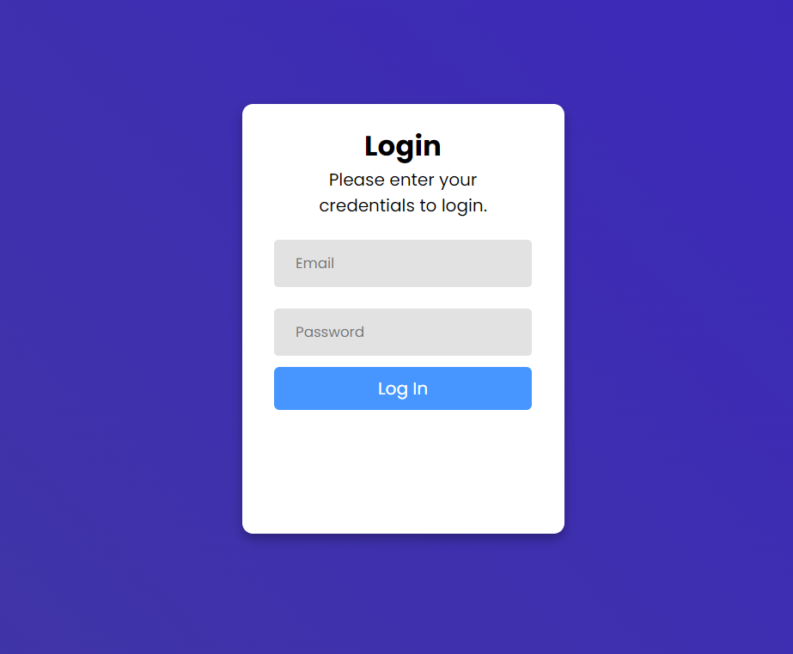

**Database Tables Involved**

* + - user_master

### 4.1.2 UC-002: Admin Portal

**Purpose**

* + - This use case describes admin portal screen in the application.

**Actors**

* + - The actor(s) that interact and participate in this use case are: Admin

%3CmxGraphModel%3E%3Croot%3E%3CmxCell%20id%3D%220%22%2F%3E%3CmxCell%20id%3D%221%22%20parent%3D%220%22%2F%3E%3CmxCell%20id%3D%222%22%20value%3D%22%22%20style%3D%22rounded%3D0%3BwhiteSpace%3Dwrap%3Bhtml%3D1%3B%22%20vertex%3D%221%22%20parent%3D%221%22%3E%3CmxGeometry%20x%3D%22120%22%20y%3D%22250%22%20width%3D%22450%22%20height%3D%22150%22%20as%3D%22geometry%22%2F%3E%3C%2FmxCell%3E%3C%2Froot%3E%3C%2FmxGraphModel%3E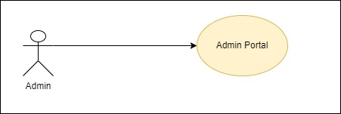

**Pre-Conditions**

* + - Application should be running on the device.
    - The user must be logged in.

**Post-Conditions**

* + - Admin Portal screen with asset and budget screen should be displayed to the user.

**Basic Flow**

* + - Admin Portal Screen will be displayed.
    - The User can interact with Assets Counts and Budget Data cards.
    - The User can Register New Asset and add Budget information

**Alternate Flow (Password is incorrect)**

* + - NA

**Failure Case**

* NA

**Screen Design**

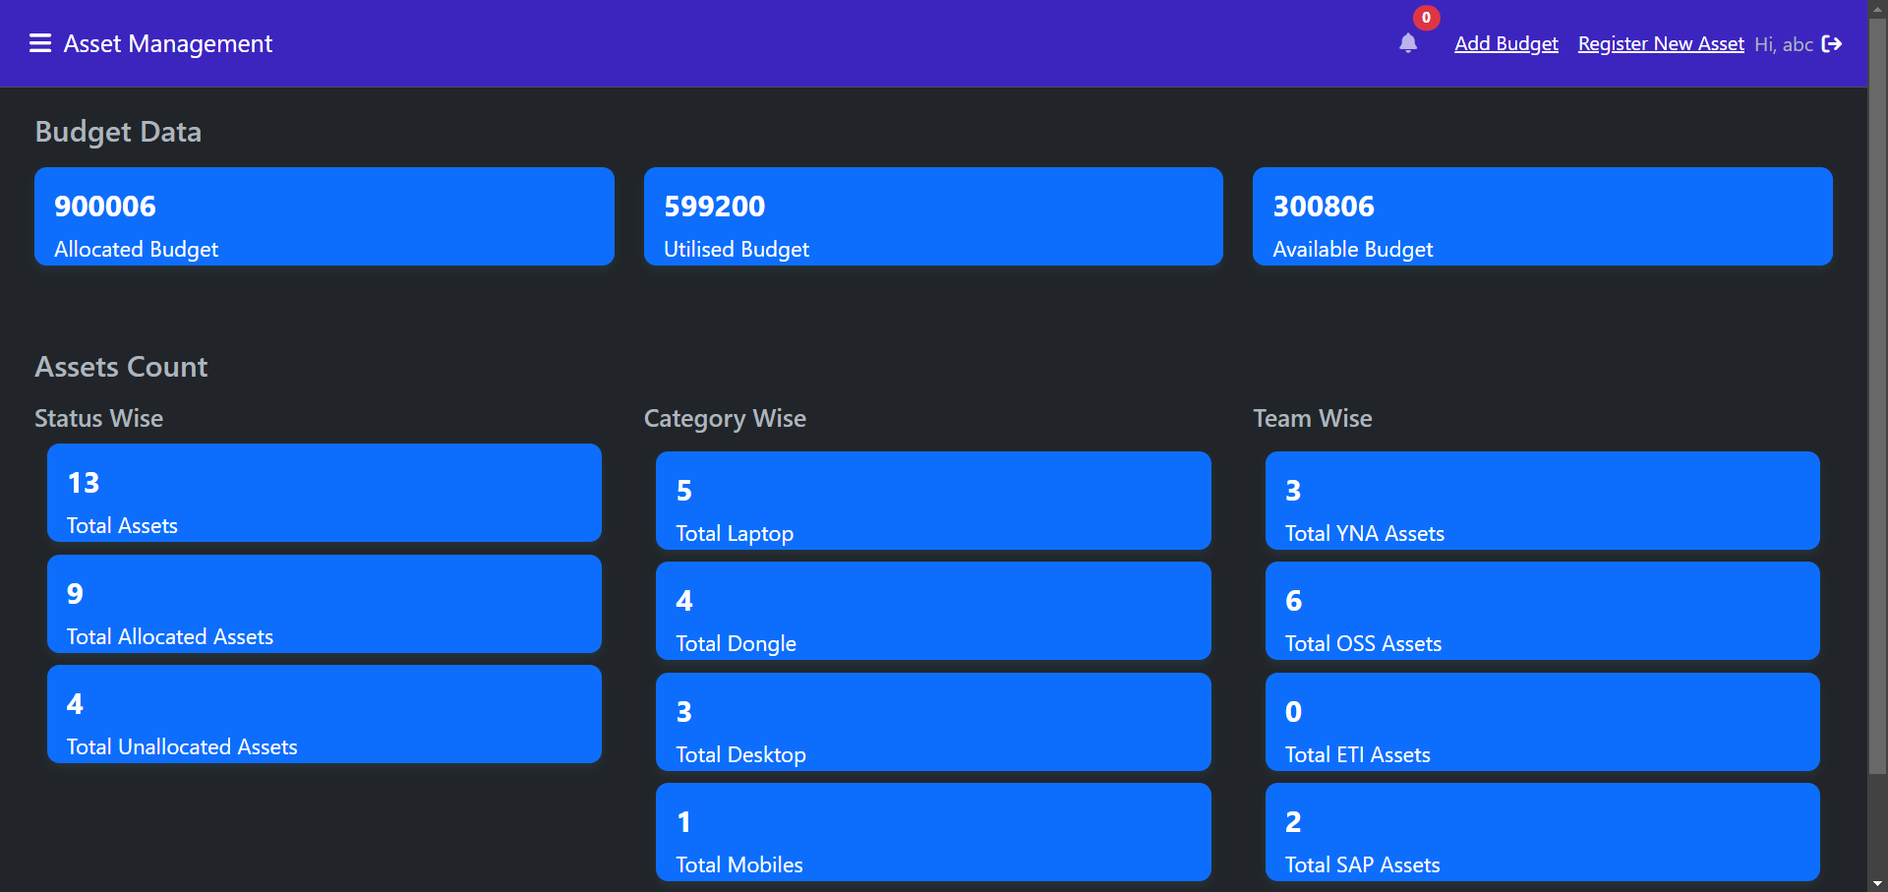

**Database Tables Involved**

* + - asset_master
    - asset_budget_master

### 4.1.3 UC-003: Asset Details

**Purpose**

* + - This use case describes about the asset details screen in the application.

**Actors**

* + - The actor(s) that interact and participate in this use case is: Admin

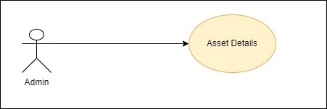

**Pre-Conditions**

* + - Application should be running on the device.
    - The user must be logged in inside the application.

**Post-Conditions**

* + - Asset Details screen is displayed and user can interact with buttons in the action column of the asset details table.

**Basic Flow**

* + - Asset Details Screen is displayed to user.
    - User can interact with View button and user will be redirected to Asset History screen .
    - User can interact with Update button and update asset details modal should be displayed.

**Alternate Flow(Bug data is duplicate)**

* + - NA

**Failure Case**

* + - NA

**Screen Design**

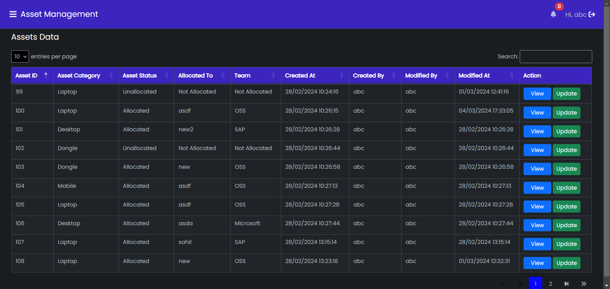

**Database Tables Involved**

* + - asset_master

### 4.1.4 UC-004: Update Asset Details

**Purpose**

* + - This use case describes how the user will update asset details.

**Actors**

* + - The actor(s) that interact and participate in this use case is: User

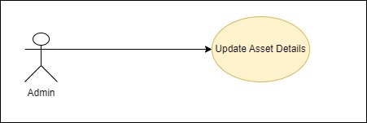

**Pre-Conditions**

* + - The user must be logged in inside the application.

**Post-Conditions**

* + - Asset details will be updated and asset details screen will be refreshed.

**Basic Flow**

* + - Update asset Details modal is displayed to the user.
    - User clicks on Update button.
    - Sweet alert message is displayed and asset Details screen will be refreshed.

**Alternate Flow (Asset status is Allocated)**

* + - User selected Allocated as the asset status.
    - Team and Allocated To field will be displayed to the user.
    - User will select from the team dropdown and employee from the allocated to dropdown field.
    - User clicks on the Update button and success sweet alert message is displayed.
    - Asset Details screen will be refreshed.

**Alternate Flow (Asset status is Unllocated)**

* + - User selected Unallocated as the asset status.
    - User clicks on the Update button and success sweet alert message is displayed.
    - Asset Details screen will be refreshed.

**Alternate Flow(Asset status is Allocated)**

* + - User enters employee name or employee id without selecting from the Allocated To dropdown field.
    - User clicks on Update button.
    - Sweet error alert message will be displayed.
    - Asset Details will not be updated
    - Update Asset Detail modal will be closed.

**Failure Case**

* NA

**Screen Design**

**Database Tables Involved**

* + - asset_master

### 4.1.5 UC-005: Asset History

**Purpose**

* + - This use case describes how the Asset History screen will be displayed to the user.

**Actors**

* + - The actor(s) that interact and participate in this use case is: Admin

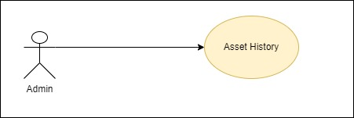

**Pre-Conditions**

* + - The user must be logged in inside the application.
    - The user should be in Asset Details screen.

**Post-Conditions**

* + - Asset History will be displayed properly.

**Basic Flow**

* + - User clicks on view button on the asset details screen.
    - User will be navigated to Asset History screen.
    - Detailed information of asset history for respective asset will be dispayed to the user.

**Failure Case**

* NA

**Screen Design**

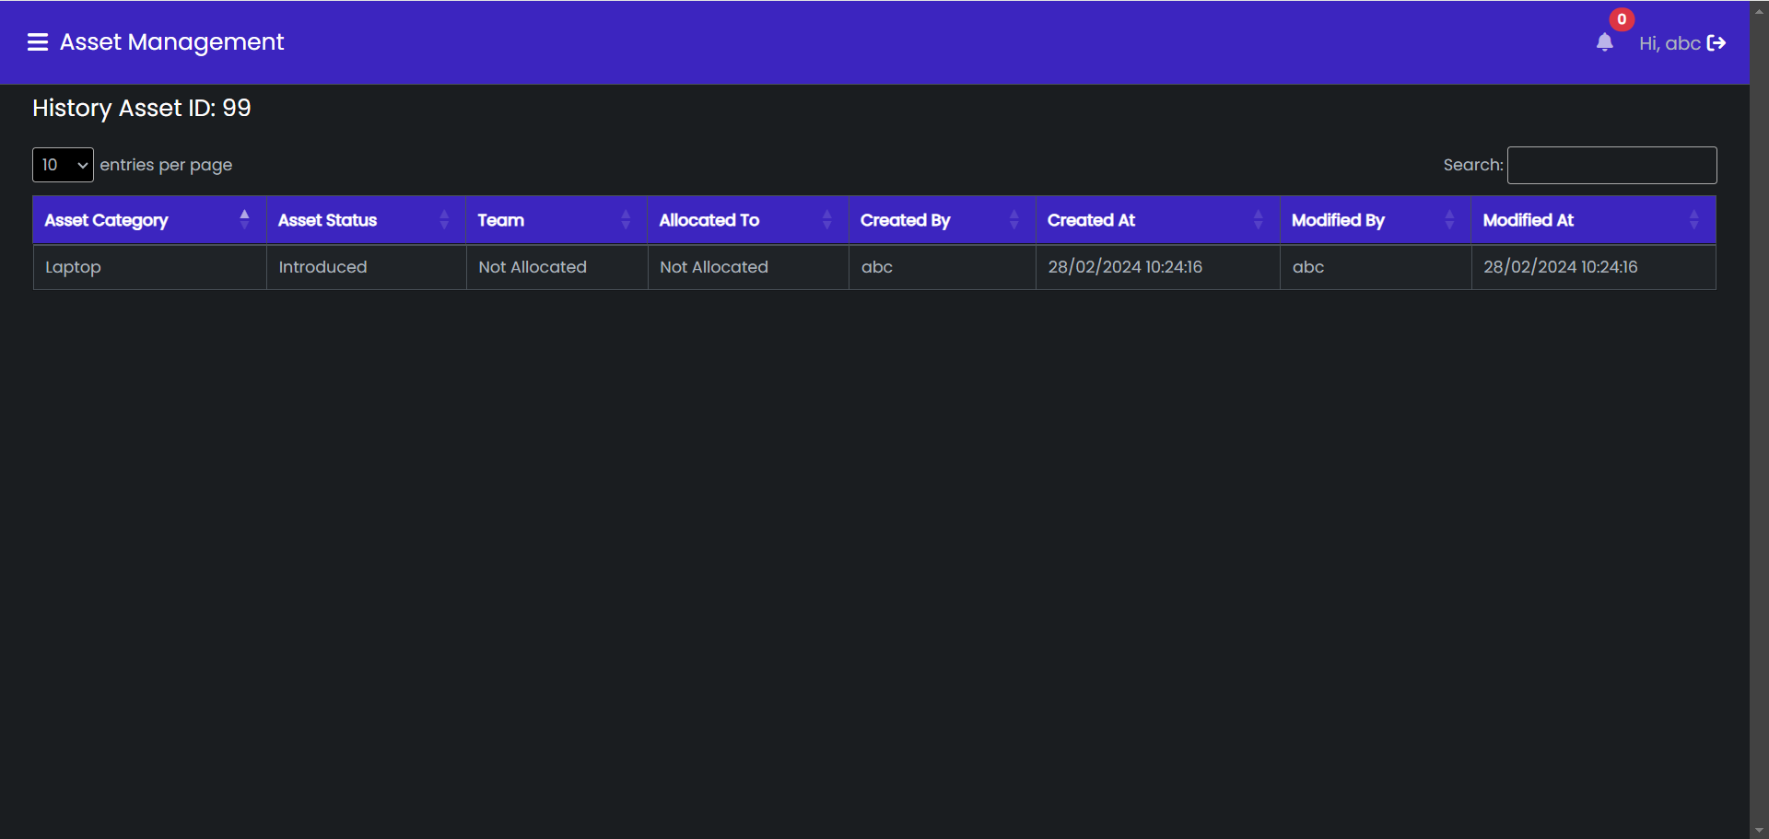

**Database Tables Involved**

* + - asset_history

### 4.1.6 UC-006: Add budget

**Purpose**

* + - This use use case describes how the user will edit the bug details.

**Actors**

* + - The actor(s) that interact and participate in this use case is: User

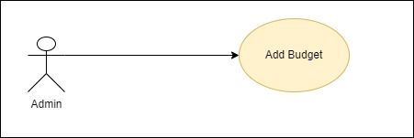

**Pre-Conditions**

* + - The user must be logged in inside the application.
    - The user must be on Admin Portal screen.

**Post-Conditions**

* + - Budget Data will be added and admin portal screen will be refreshed.

**Basic Flow**

* + - User will click on Add Budget button present on Admin Portal Screen.
    - Add Budget Modal will be displayed to the user.
    - User will add the budget and clicks on the Add Budget button.
    - Budget Data will be added and Admin Portal screen will be refreshed with updated information.

**Alternate Flow (Budget data is already present)**

* + - User add the budget and clicks on Add Budget button.
    - A sweet alert message with value ‘Budget for year already exists’ is shown to the user.

**Failure Case**

* + - NA

**Validations**

* + - Allocated Budget: Required and should be a number and greater than 0.

**Screen Design**

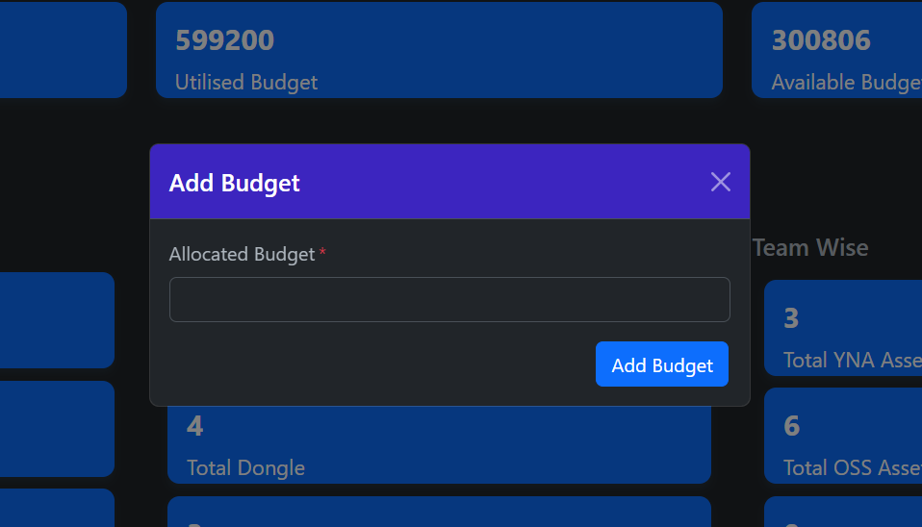

**Database Tables Involved**

* + - asset_budget_master

### 4.1.7 UC-007: Update Budget

**Purpose**

* + - This use case describes how admin will update budget .

**Actors**

* + - The actor(s) that interact and participate in this use case is: Admin

**Pre-Conditions**

* + - The application must be running properly on device.
    - Admin portal screen should be displayed.

**Post-Conditions**

* + - Budget will be updated and admin portal screen will be refreshed with updated information.

**Basic Flow**

* + - User is Admin Portal screen.
    - User clicks on any card under Budget Data heading.
    - Update Budget modal will be displayed prefilled with current allocated budget.
    - User will click on update budget button and sweet success alert message will be displayed.
    - Update budget modal will be closed and admin portal screen will be refreshed and updayted information will be displayed.

**Alternate Flow (New budget is less than current allocated budget)**

* + - User clicks on update bnudget button.
    - A sweet warning message with value ‘New allocated budget cannot be less than current allocated budget’ is shown.

**Failure Case**

* NA

**Screen Design**

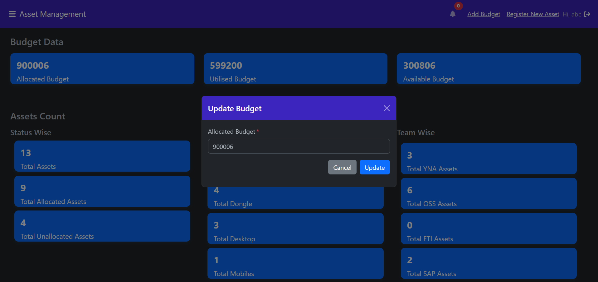

**Database Tables Involved**

* + - asset_budget_master

### 4.1.8 UC-008: Register New Asset

**Purpose**

* This use case describes how user will register new asset in the application.

**Actor**

* The actor(s) that interact and participate in this use case is: Admin

**Pre-conditions**

* User must be logged in inside the application.
* Admin Portal screen should be displayed.

**Post-conditions**

* New asset should be registered and sweet alert message should be displayed.
* Admin Portal screen should be refreshed with updated information.

**Basic Flow**

* User should be on Admin Portal screen.
* User will click on Register New Asset button in the navbar and Register New Asset Modal will be displayed.
* User will click on Register Asset button and swal success message will be displayed.
* Register New Asset modal will be closed and Admin Portal screen will be refreshed.
* Admin Portal screen will be displayed with updated information.

**Alternate Flow(Asset status is unallocated)**

* Team and Allocated To dropdown fields will not be displayed.
* User clicks on Register Asset button and swal success message will be displayed
* Admin Portal screen will be refreshed with updated information.

**Alternate Flow(Asset status is allocated)**

* Team and Allocated To dropdown fields will be displayed.
* User selects team and employee from the Team and Allocated To dropdown fields respectively
* User clicks on Register Asset button and swal success message will be displayed.
* Admin Portal screen will be refreshed with updated information.

**Alternate Flow(Asset status is allocated)**

* Employee is not selected from the Allocated To dropdown field .
* User clicks on the Register Asset button and sweet warning message will be displayed.
* Register New Asset modal will be closed.

**Failure Case**

* NA

**Screen Design**

**Database Table Involved**

* asset_master

### 4.1.9 UC-009: Add User

**Purpose**

* This use case describes how the user will add new user in the application.

**Actors**

* The actor(s) that interact and participate in this use case is: Admin

**Pre-conditions**

* User must be logged in inside the application.
* Admin Portal screen should be displayed.

**Post-conditions**

* New User will be added in the application.
* User will be redirected to Admin Portal screen.

**Basic Flow**

* User clicks on Add User button from the sidebar on the Admin Portal Screen.
* User should be redirected to Add User screen.
* User should fill register user form.
* User clicks on the Register button.
* Sweet success message should be displayed and user should be navigated to Admin Portal

screen.

**Alternate Flow**

* NA

**Failure Case**

* NA

**Validations**

* Username: Required
* Email: Required and it should be in email format.
* Password: It should be of atleast 8 characters, 1 special character, 1lowercase and 1 uppercase letters and 1 number.
* Team: Required and should be selected from the dropdown.
* User Role: Required and should be selected from the dropdown.

**Screen Design**

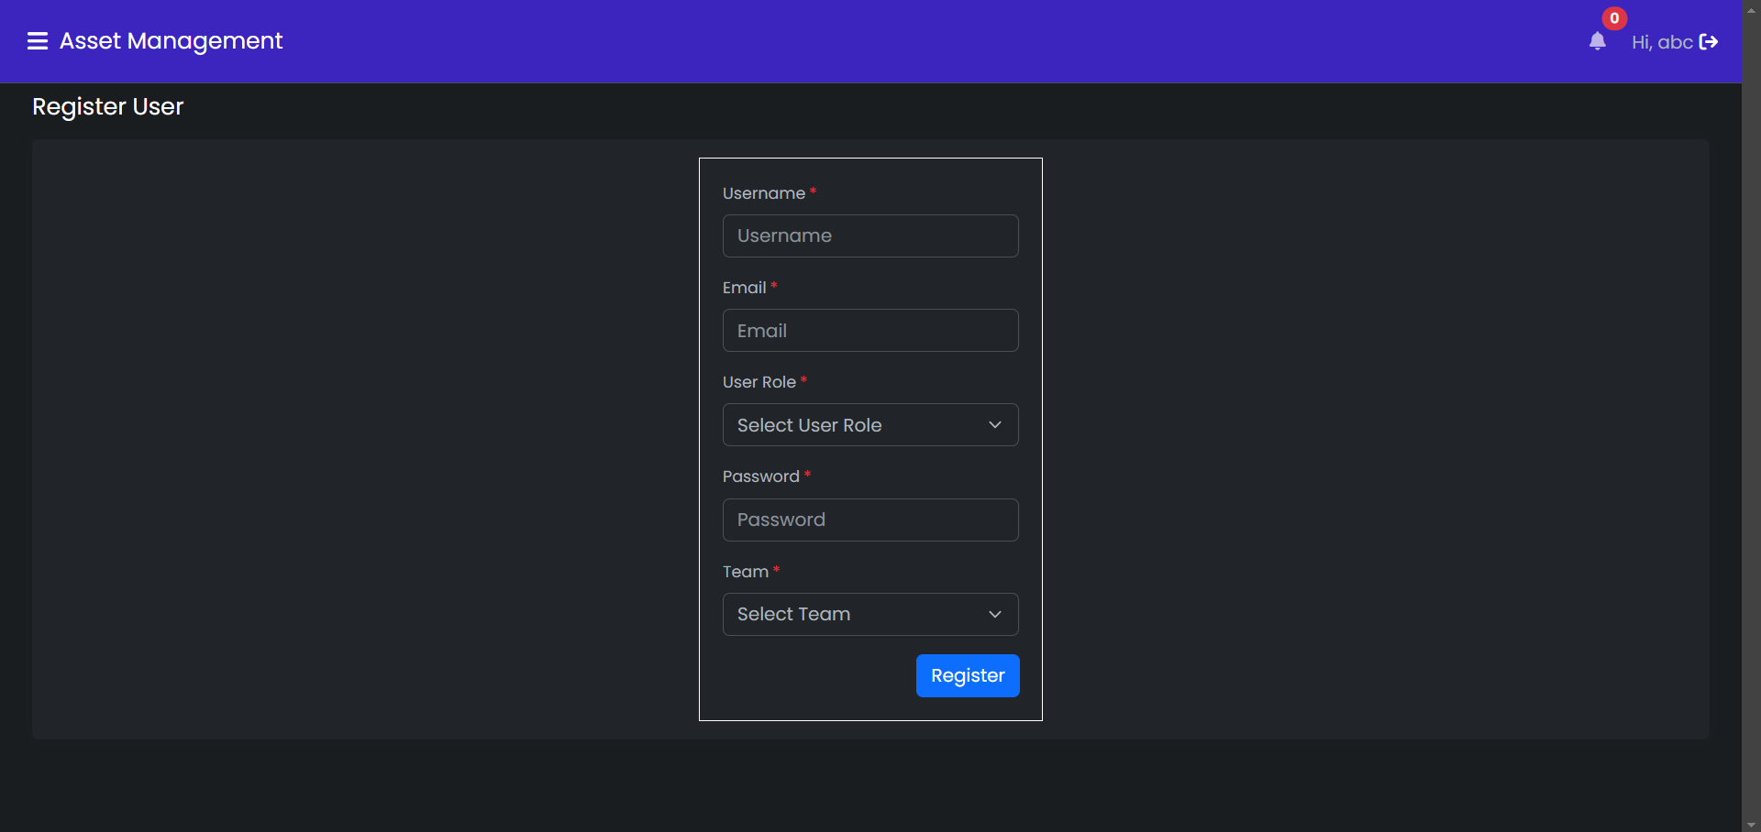

**Database Table Imvolved**

* user_master

### 4.1.10 UC-010: Add Vendor

**Purpose**

* + - This use case describes how the user will add vendor in the application.

**Actors**

* + - The actor(s) that interact and participate in this use case is: Admin

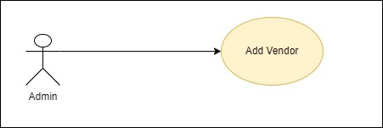

**Pre-conditions**

* User must be logged in inside the application.
* Admin Portal screen should be displayed.

**Post-conditions**

* New Vendor will be added in the application.
* User will be redirected to Admin Portal screen.

**Basic Flow**

* User clicks on Add Vendor button from the sidebar on the Admin Portal screen.
* User should be redirected to Add Vendor screen.
* User should fill register vendor form.
* User clicks on the Register button.
* Sweet success message should be displayed and user should be navigated to Admin Portal

screen.

**Alternate Flow**

* NA

**Failure Case**

* NA

**Validations**

* Vendor Name: Required
* Vendor Email: Required and it should be in email format.
* Vendor Contact Number: Required and it should be of 10 digits only.
* Vendor Address: Required .
* Asset Price Per Unit: Required and it should be positive integer.

**Screen Design**

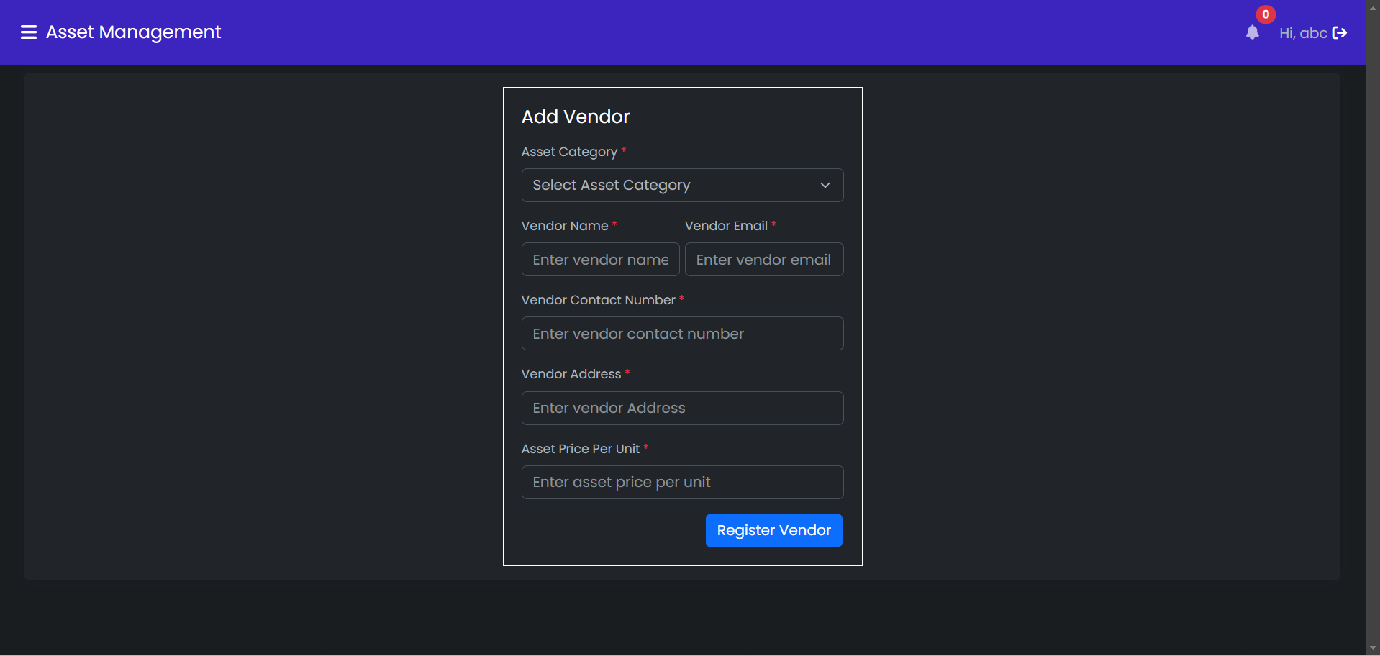

**Database Table Involved**

* asset_vendor_master

### 4.1.11 UC-011: Track Issues

**Purpose**

* This use case describes how the user track issues in the application.

**Actors**

* The actor(s) that interact and participate in this use case is: Admin

**Pre-conditions**

* User must be logged in inside the application.
* Admin Portal screen should be displayed.

**Post-conditions**

* Track issues screen should be displayed to the user.

**Basic Flow**

* User clicks on Track Issues button from the sidebar on the Admin Portal screen.
* User should be redirected to Track Issues screen.
* Track Issues should be displayed with issues and new asset requests cards.

**Alternate Flow**

* NA

**Failure Case**

* NA

**Screen Design**

**Database Table Involved**

* asset_issue_master
* asset_request_master

### 4.1.12 UC-012: Update Request/Issue Status

**Purpose**

* + - This use case describes how the user should update request/issue status application.

**Actors**

* + - The actor(s) that interact and participate in this use case is: Admin

**Pre-conditions**

* User must be logged in the application
* User should be on Track Issue screen

**Post-conditions**

* Issue status should be updated
* User should be redirected to the Pending Issues screen.

**Basic Flow**

* User clicks on card on the Track Issues screen.
* User should be redirected to Pending Issues screen.
* User clicks on Update Button in the pending issues or request table.
* Update Request/Issue status Modal should be displayed.
* User clicks on Update Button.
* Sweet success alert message should be displayed.
* User should be redirected to the pending issues screen with updated information

**Alternate Flow**

* NA

**Failure Case**

* NA

**Screen Design**

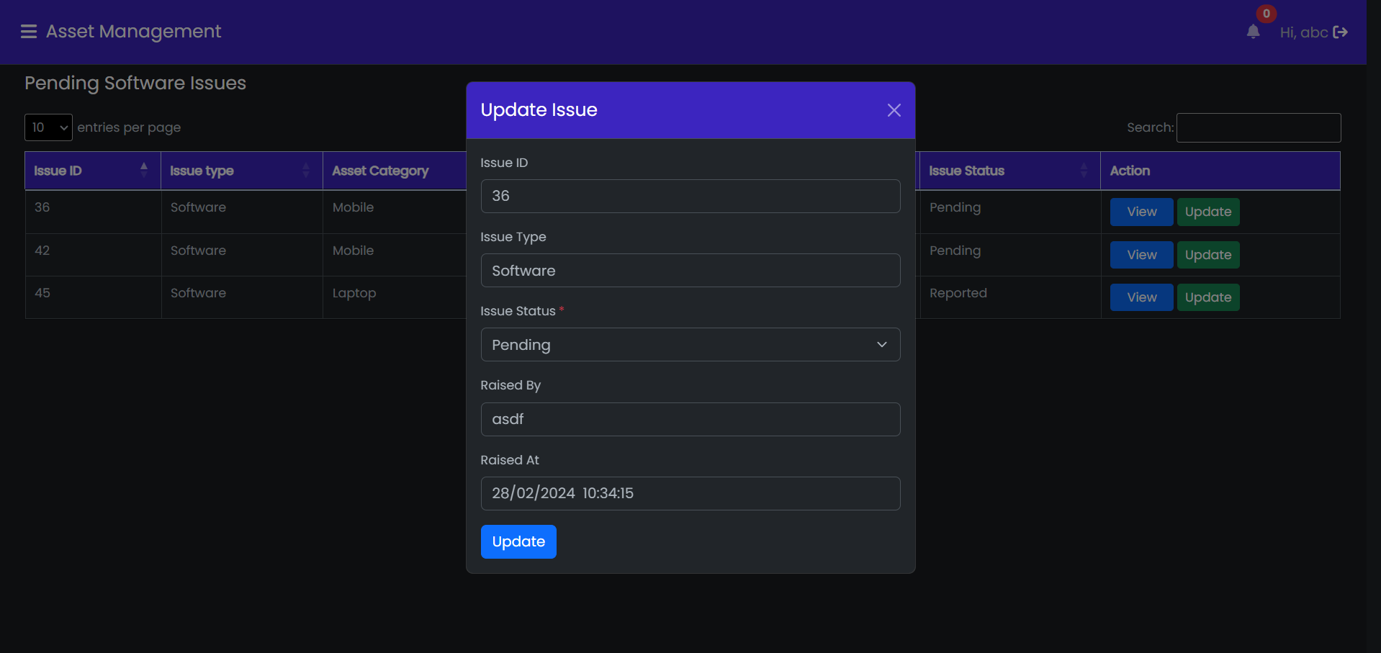

**Database Table Involved**

* asset_issue_master
* asset_request_master

### 4.1.13 UC-013: Employee Portal

**Purpose**

* The use case describes how the employee will see assets allocated him and issues he raised.

**Actors**

* The actor(s) that interact and participate in this use case is: Employee

**Pre-conditions**

* Employee user should be logged in the application.

**Post-conditions**

* Employee Portal screen should be displayed.

**Basic Flow**

* Employee user should login with correct credentianls
* Employee portal screen should be displayed
* Employee Portal should properly show allocated assets to the employee and assets raised by the employees.

**Alternate Flow**

* NA

**Failure Case**

* NA

**Screen Design**

**Database Table Involved**

* asset_issue_master
* asset_request_master

### 4.1.14 UC-014 Request New Asset

**Purpose**

* The use case describes how the employee should request new assets allocated him.

**Actors**

* The actor(s) that interact and participate in this use case is: Employee

**Pre-conditions**

* Employee user should be logged in the application.
* Employee portal screen should be displayed

**Post-conditions**

* New asset request should be raised
* Issues table should be updated with new information

**Basic Flow**

* User should be on employee portal screen.
* User clicks on the request new asset button in the navbar.
* Request New Asset modal should be displayed.
* User click on Request Asset button.
* Sweet success alert message should be displayed
* Issue table should be updated with new information.

**Alternate Flow**

* NA

**Failure Case**

* NA

**Screen Design**

**Database Table Involved**

* asset_request_master

### 4.1.15 UC-015: Report Issue

Purpose

* The use case describes how the employee should report issues see in the application.

Actors

* The actor(s) that interact and participate in this use case is: Employee

**Pre-conditions**

* User should be logged in the application
* Employee Portal should be displayed

**Post-conditions**

* Issue should be raised and sweet success alert message should be displayed.
* Issue table should be updated with updated information.

**Basic Flow**

* User clicks on the Report Issue button in the allocated assets table.
* Report Issue modal should be displayed.
* User should clicks on report issue button
* Issue should be updated in the database and sweet success message should be displayed.
* Report Issue modal should be closed.

**Alternate Issue**

* NA

**Failure Case**

* NA

**Screen Design**

**Database Table Involved**

* asset_issue_master

### 4.1.16 UC-016: Logout

**Purpose**

* + - This use case describes how the user will be logged out of the application.

**Actors**

* + - The actor(s) that interact and participate in this use case is: Admin

**Pre-Conditions**

* + - User must be logged in inside the application.

**Post-Conditions**

* + - User will get logged out from the application.

**Basic Flow**

* + - User Clicks on ‘Logout’ button.
    - User will be logged out from the application.

**Screen Design**

**Database Tables Involved**

* + - NA

### 4.1.17 UC-017 Add Quotation

**Purpose**

* + - This use case describes how the user should add quotation in the application.

**Actors**

* + - The actor(s) that interact and participate in this use case is: Admin

**Pre-conditions**

* User should be logged in the application
* Admin Portal screen should be displayed

**Post-conditions**

* Vendor quotations should be added and uploaded.

**Basic Flow**

* User should be on Admin Portal screen.
* User should click on Add quotation button in the sidebar.
* Add quotation screen should be displayed.
* On click of add quotation button from the vendor details table in the add quotation screen.
* Upload file widget should be displayed.
* Selected file should be uploaded and sweet success alert message should be displayed.
* Add quotation screen should be refreshed with updated information.

**Alternate Flow(Selected file size is more than 10 MB)**

* Selected file size is 10 MB.
* File should not be uploaded and error message should be displayed in the upload file widget.

**Failure Case**

* NA

**Validations**

* File size should be less than or equal to 10 MB.
* File should be of docs or pdf format.

**Screen Design**

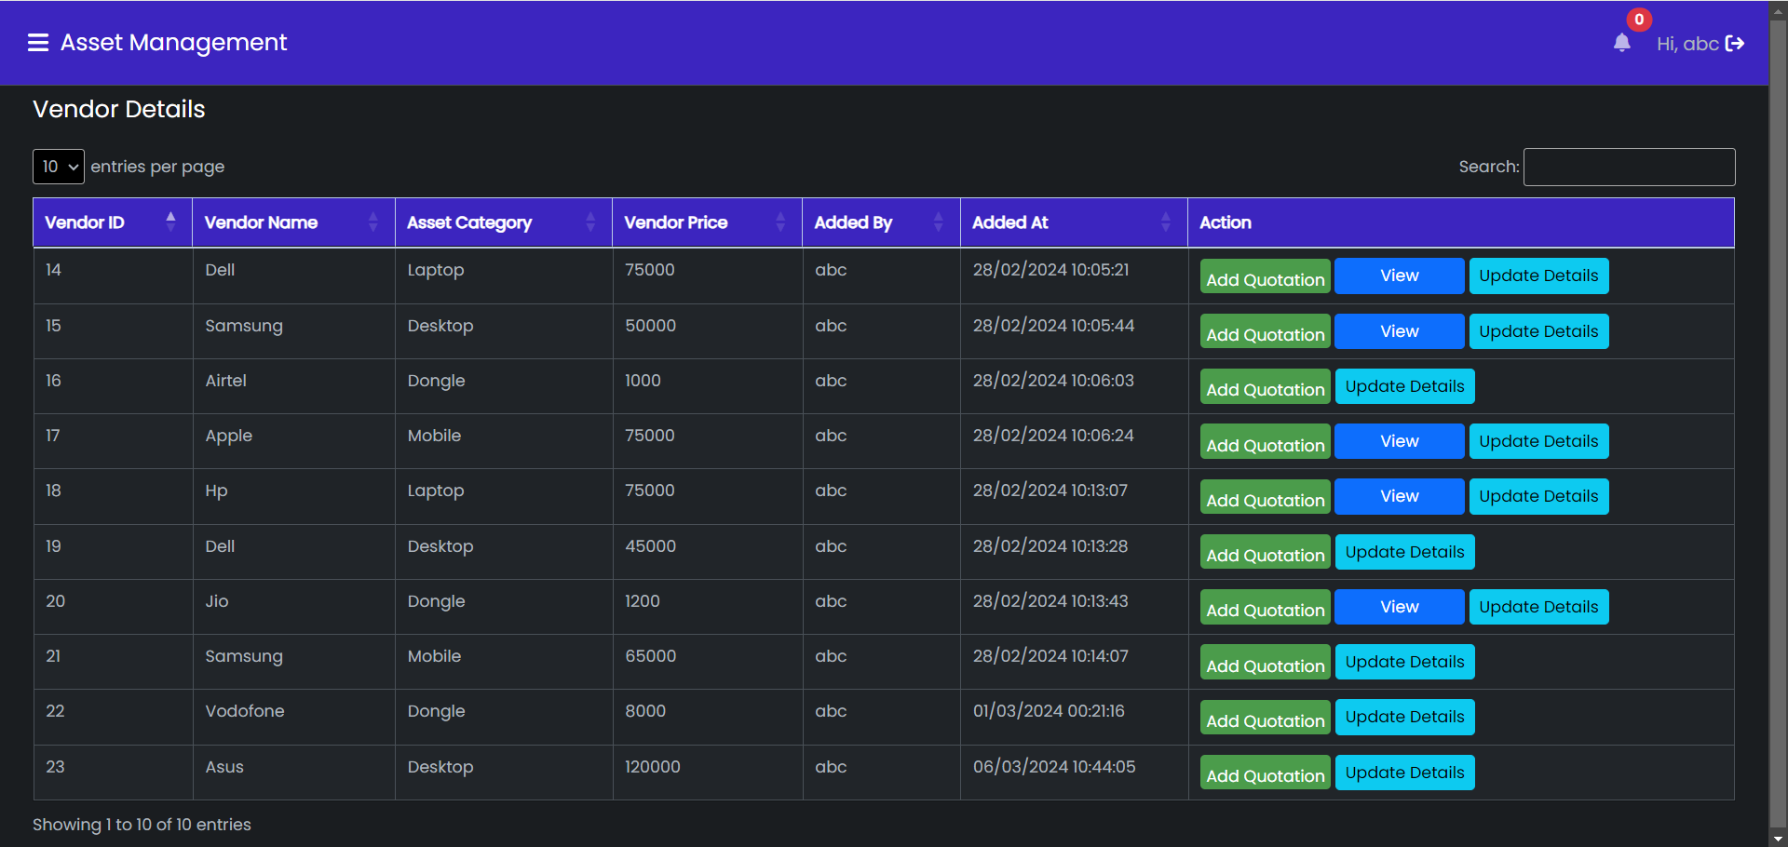

**Database Table Involved**

* asset_vendor_master

### 4.1.18 UC-018: Update Quotation Details

**Purpose**

* + - This use case describes how the user should upload quotation in the application.

**Actors**

* + - The actor(s) that interact and participate in this use case is: Admin

**Pre-condition**

* User should be logged in application.
* Add Quotation screen should be displayed.

**Post-condition**

* Quotation details screen should be displayed.
* Update quotation screen should be refreshed with updated information.

**Basic Flow**

* Quotation details screen should be displayed.
* User clicks on the remove button.
* Quotation should be removed from the quotation details and from the database.
* Sweet success message should be displayed and quotation details screen should be refreshed.

**Alternate Flow**

* NA

**Failure Case**

* NA

**Screen Design**

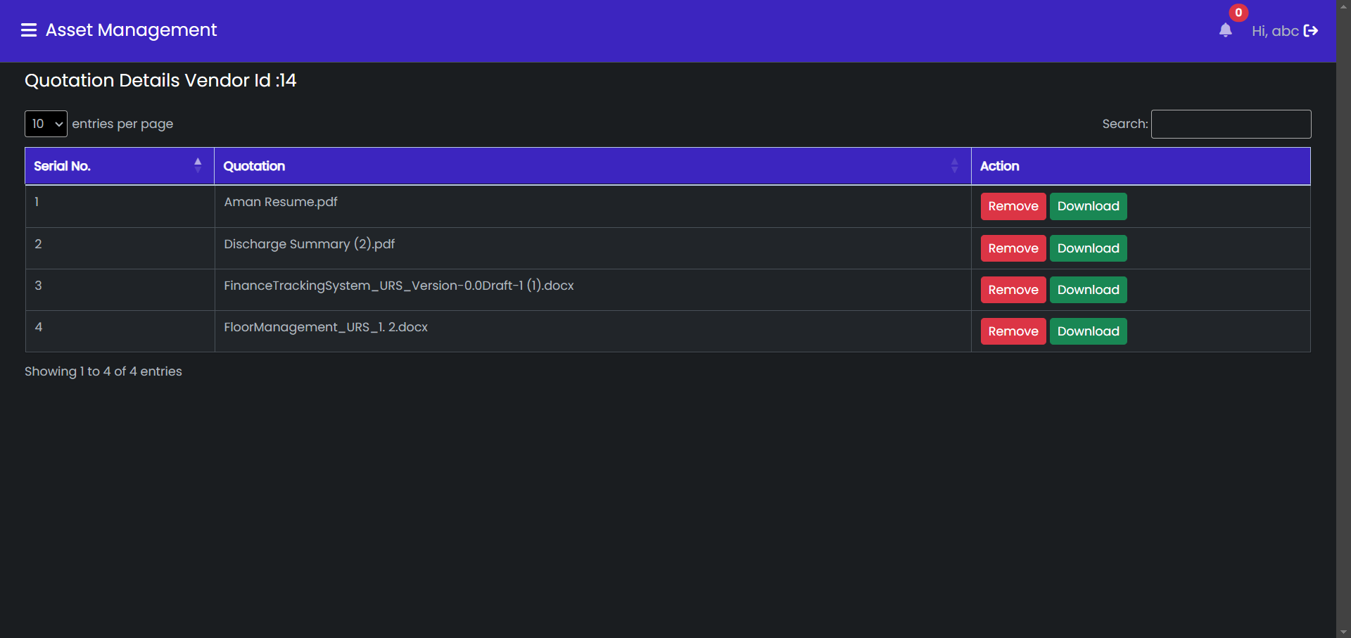

**Database Table Involved**

asset_vendor_master

### 4.1.19 UC-019: Update Vendor Details

**Purpose**

* The use case describes how the admin should update vendor details.

**Actor(s)**

* The actor(s) that interact and participate in this use case is: Employee

**Pre-conditions**

* User should be logged in the application as Admin.
* Add Quotation screen should be displayed.

**Post-conditions**

* Vendor details should be updated in the database
* Add quotation screen should be refreshed with the update information

**Basic Flow**

* Add quotation screen should be displayed.
* User clicks on the update details button.
* Update Vendor Details modal should be displayed.
* User clicks on the update button.
* Sweet success alert message should be displayed and user should be redirected to the add quotation screen.

**Alternate Flow**

* NA

**Failure Case**

* NA

**Screen Design**

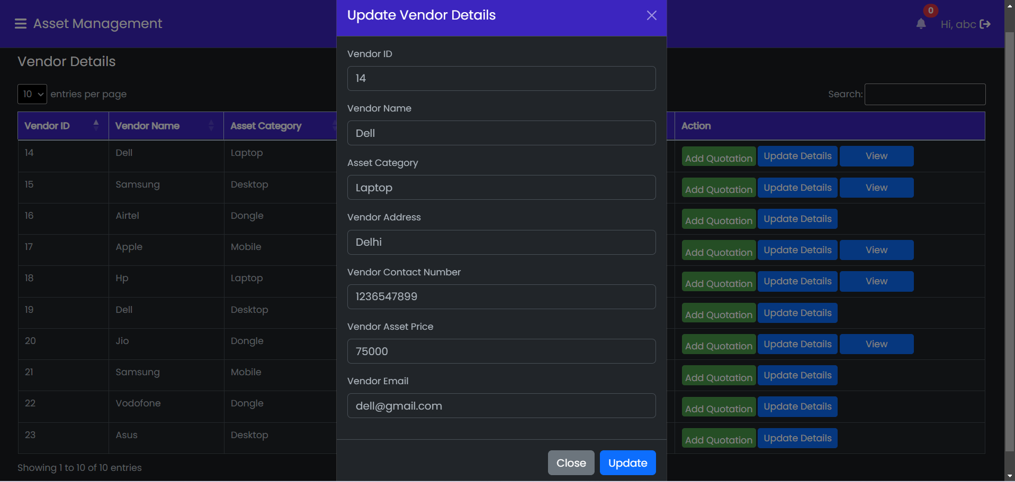

**Database Table Involved**

* asset_vendor_master